**OpenRemote**

OpenRemote setup for linux OS:

1. Install Docker in the system.

command: **sudo apt-get install docker.io**

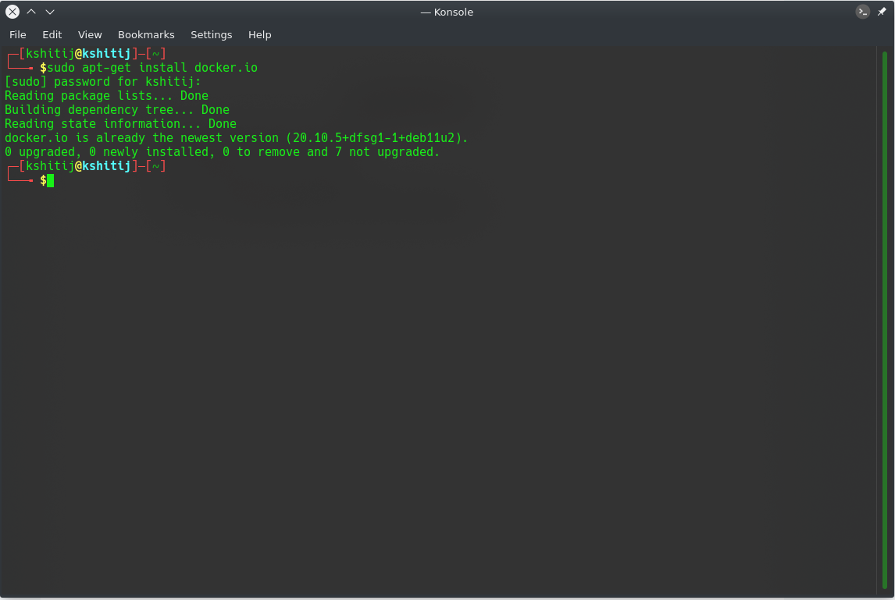

Note: The output will be little different as in this system docker is already installed.

1. Install docker compose in the system.

command: **sudo apt-get install docker-compose**

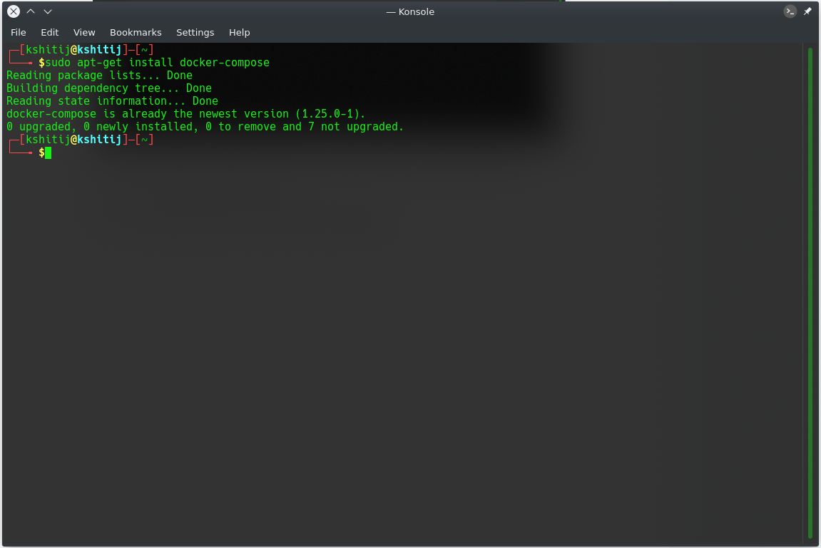

Note: The output will be little different as in this system docker compose is already installed.

1. Download the docker-compose.yml file of open remote from the repository

Visit [openRemote](https://openremote.io/get-started-iot-platform/) website

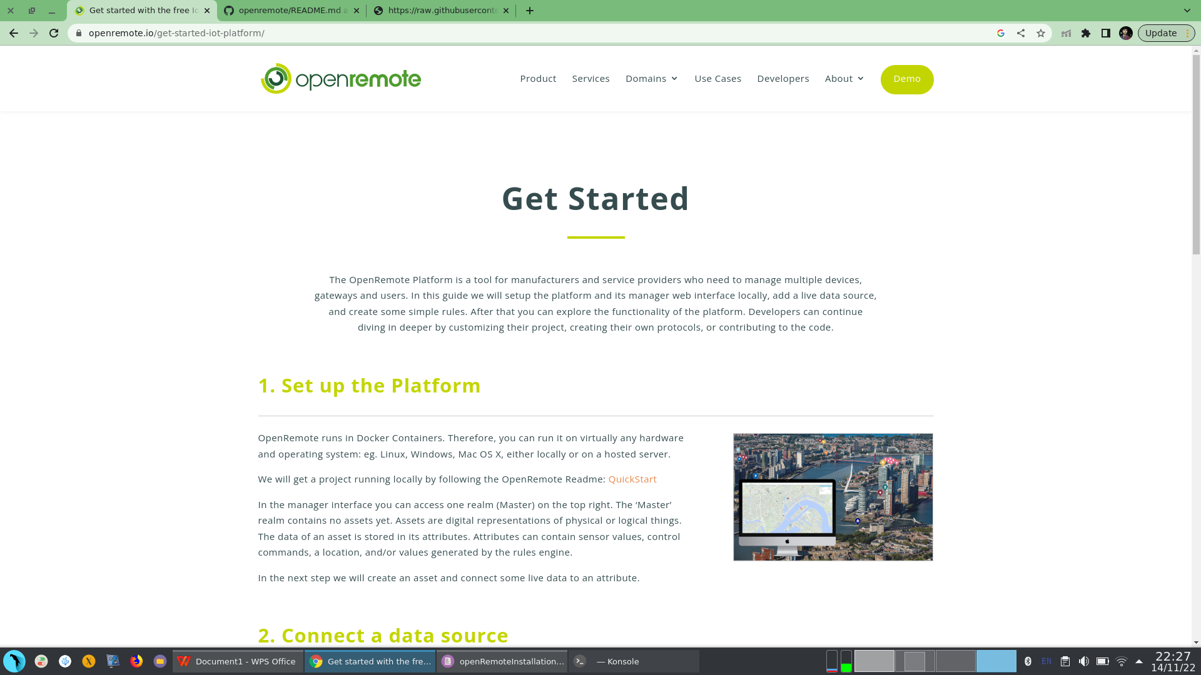

open the [Quickstart](https://github.com/openremote/openremote/blob/master/README.md) link

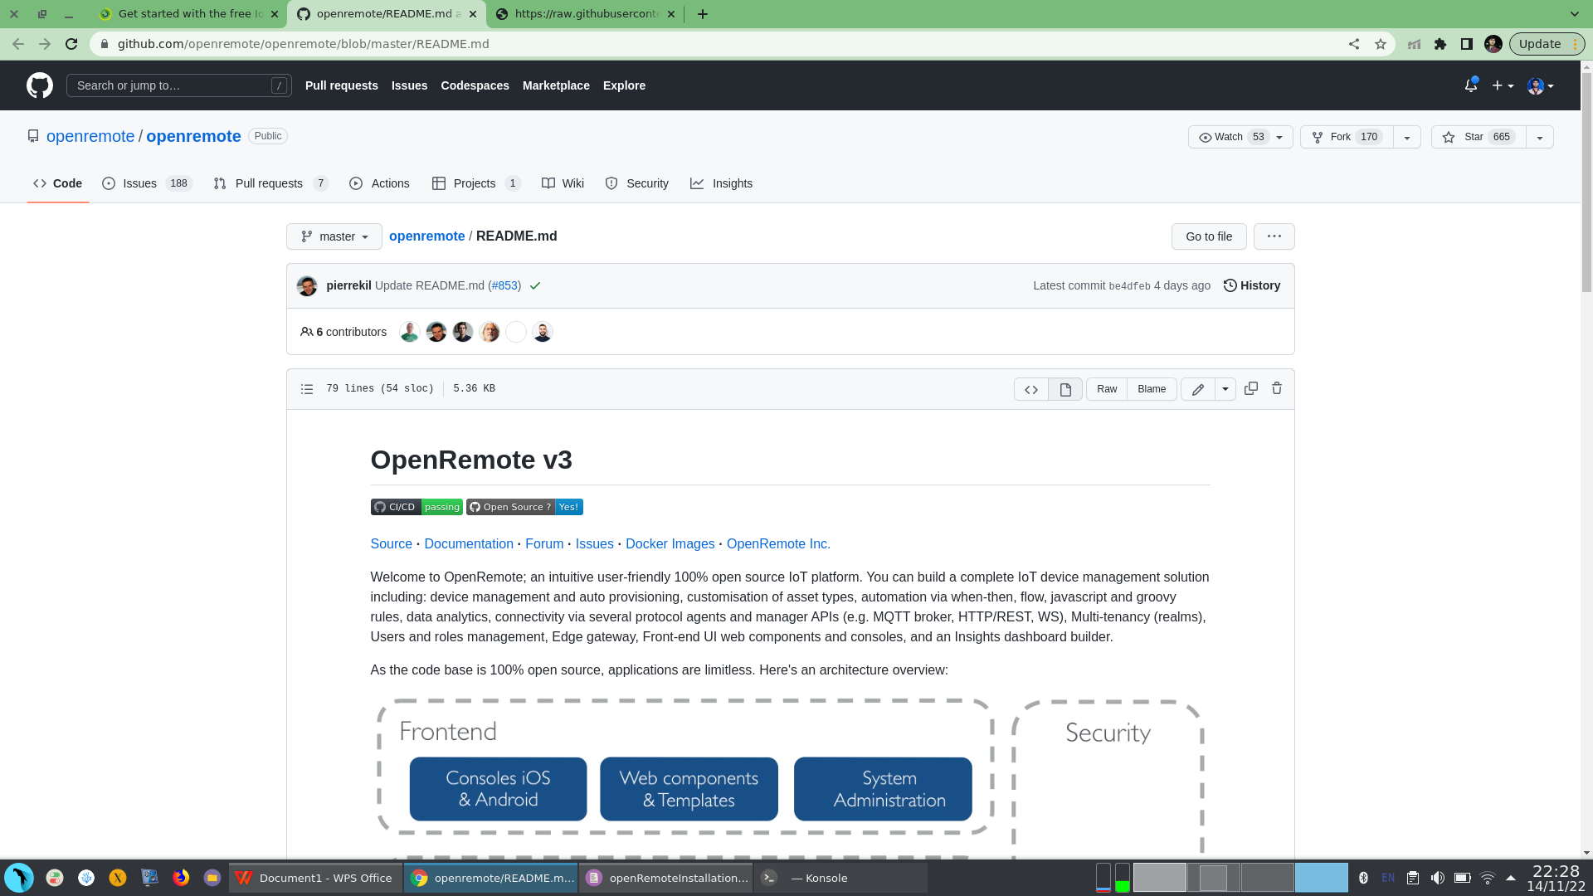

Now scroll down and find the link to download the docker-compose file

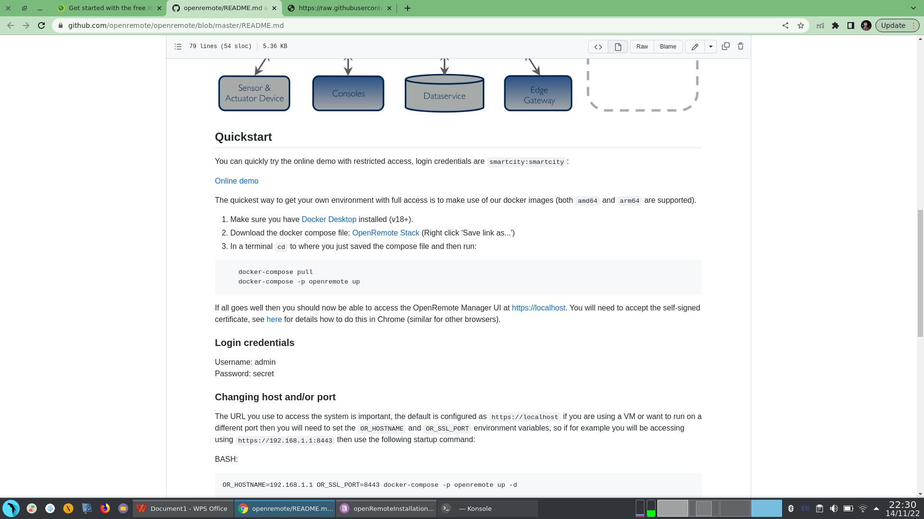

Right click on the link and save it as docker-compose.yml.

or you can use this link to download it [docker-compose](https://raw.githubusercontent.com/openremote/openremote/master/docker-compose.yml). right click on the page opened by this link and click save as and save it.

1. Now open a terminal where you have kept the docker-compose.yml file.

in my case I have kept it on my Desktop. To verify whether the file is there or not type the following command:

command: **find -name docker-compose.yml**

it should return the output as ./docker-compose.yml

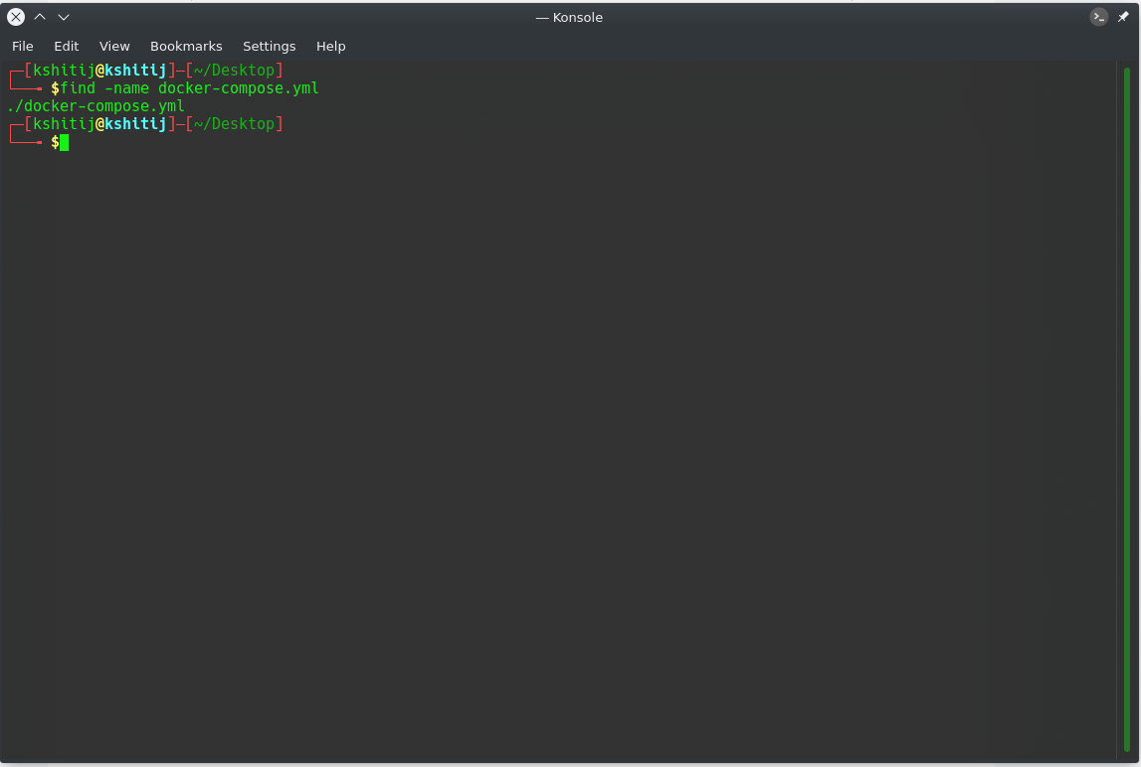

1. Now we will poll the dependencies from docker.

command: **docker-compose pull**

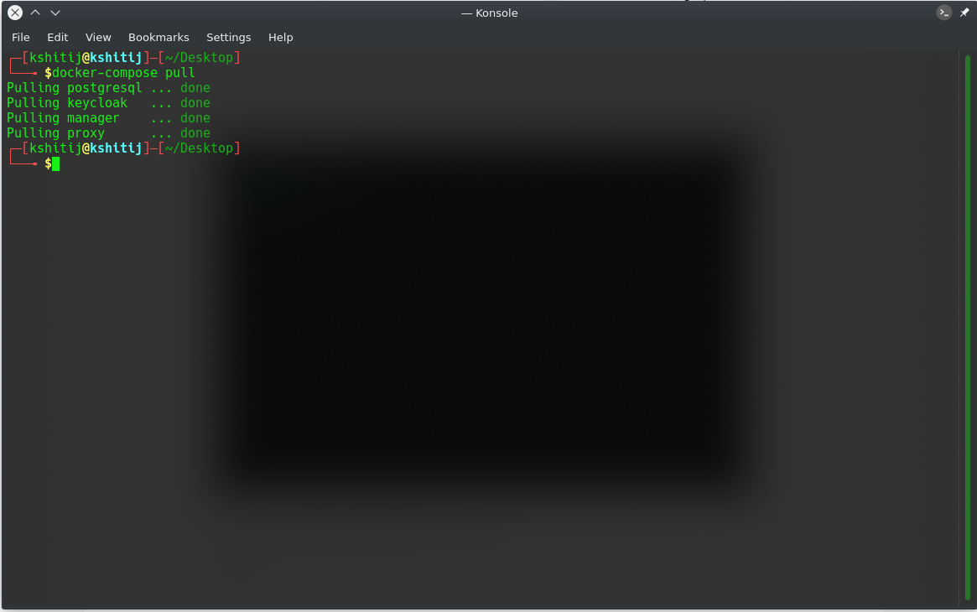

1. Now we will start the openRemote

command: **docker-compose -p openremote up**

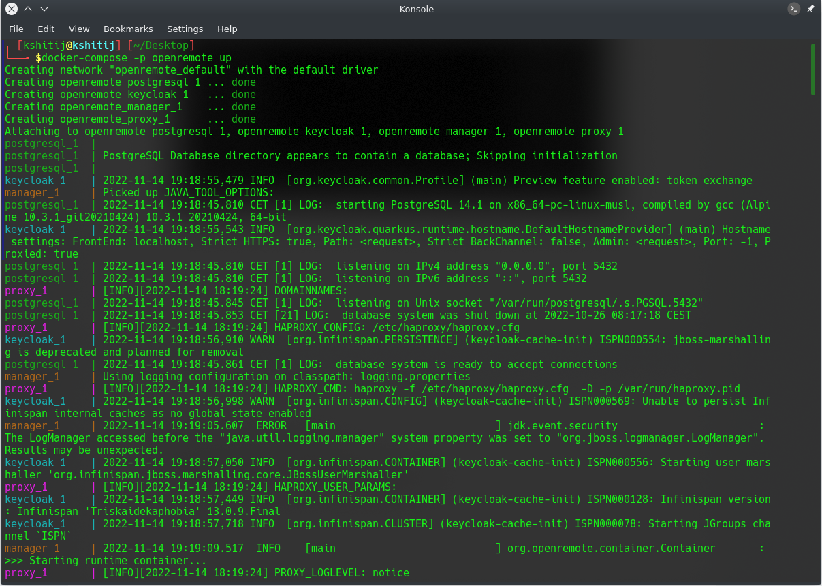

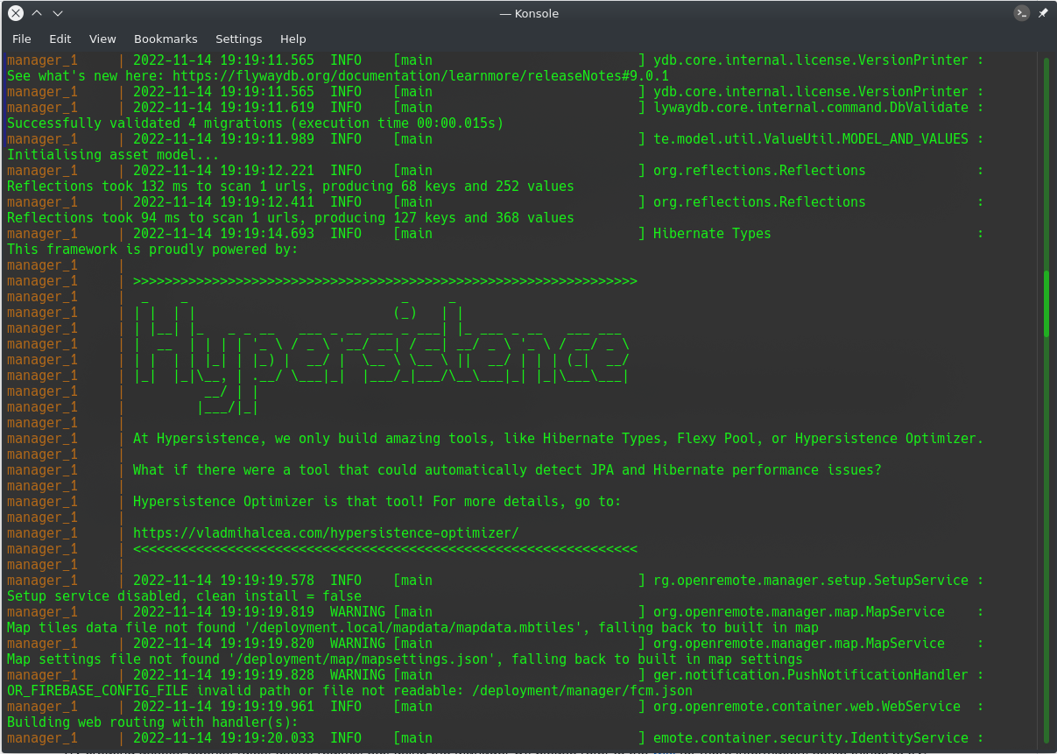

Now to view the openRemote UI open any browser and type the localhost address: <https://localhost>

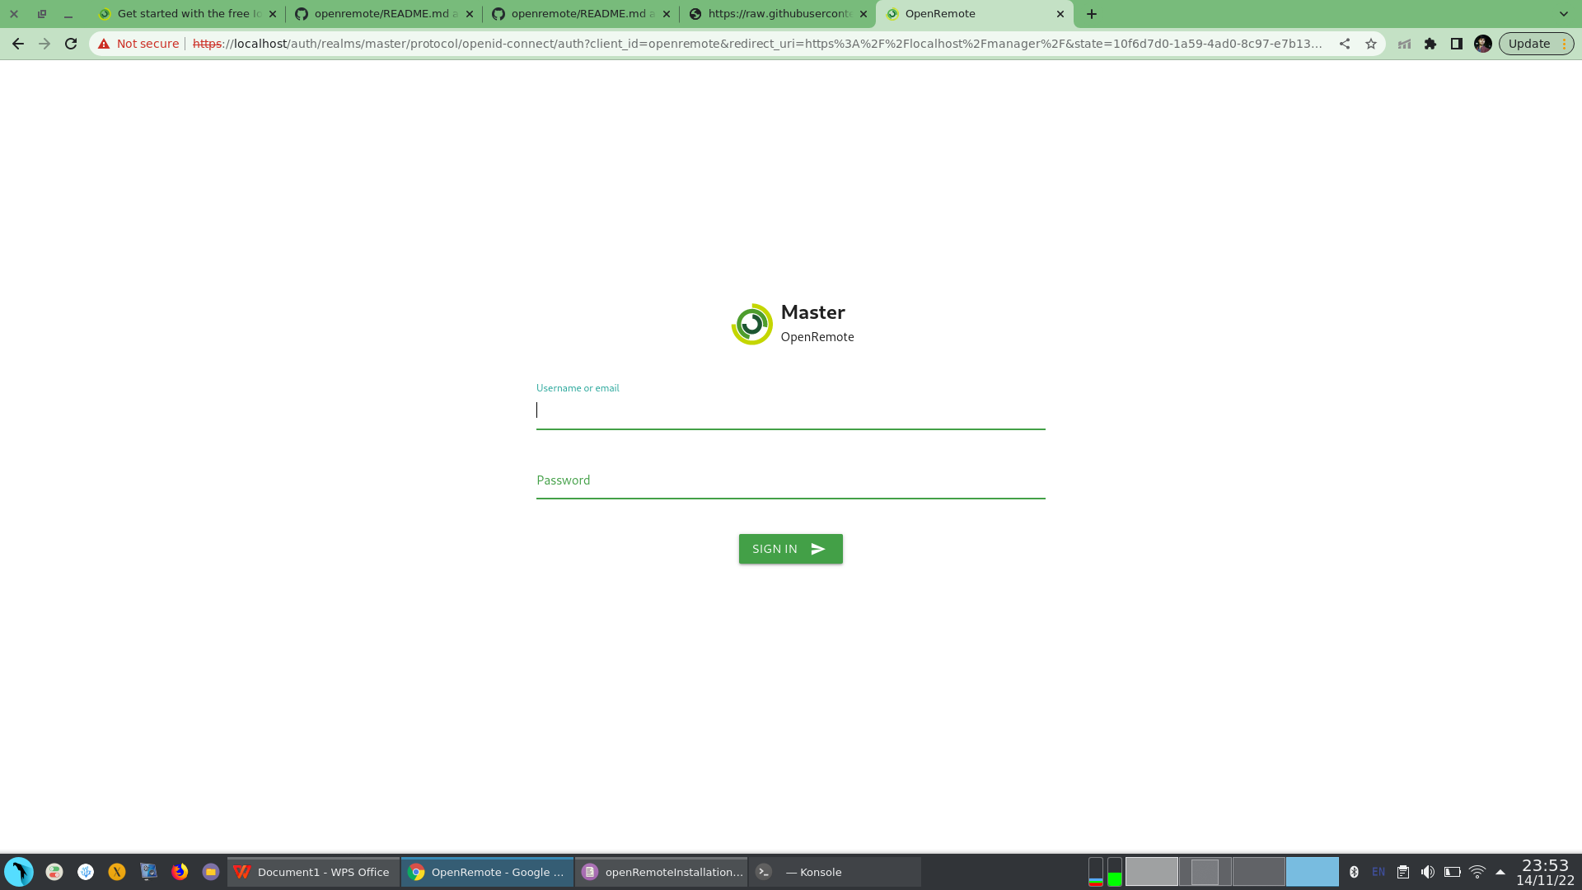

you will get this page after opening the localhost address. It may ask you to accept the risk and continue before this page depending upon your browser settings, you can just accept and continue.

The credential to login are

username: admin

password: secret

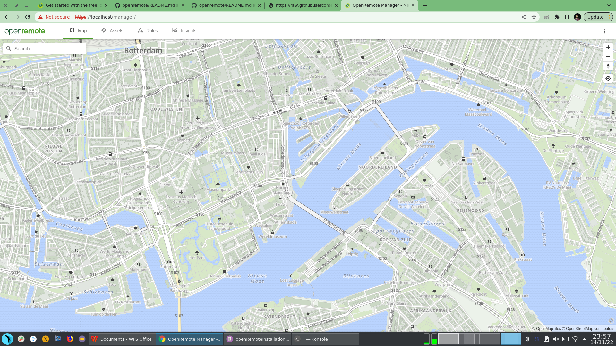

we are done with the setup.